**Group Report**

**Group 14**

**1. Problem definition (5%)**

We intend to create and develop, a brand-new smart home system, that may be applicable to all demographics. This system will be capable of connecting to other smart devices in the user’s place of residence, increasing the general comfort of everyday, home life. One of the problems we aim to address, revolves around the period of winter. During this, the house gets colder and we believe that users should be able to heat their homes before they arrive. Moreover, they should also be able to adjust and control the lighting in their house, without having to use the actual switch. A part of the smart home system we’re creating another aim we have in mind is that a lot of people tend to not be safe in the neighbourhood for many reasons so we would be also focusing on creating a security system that will help accommodate for that.

Ultimately this project intends to mitigate problems such as lack of safety in one’s own home with the use of smart cameras and door systems, as well as the wasting of power when managing the heating or lights. As the system is tailored to the user’s routine it uses less energy (e.g., turning the lights and heating off when the user is away).

**2. Expert Evaluation of an existing similar system (20%)**

The existing system most akin to our own system would be the google nest system. Google nest has a whole line of smart home products. There are comfort and security products, among which are smart: speakers, thermostats, smoke detectors, doorbells, cameras and even streaming devices.

One advantage of Google nest is that it has access to the ‘Google Knowledge Graphs.’ Its main function is that it can access an infinite number of facts and can easily answer any inquiry that the user of the smart home has. Google nest outperforms other competing voice-controlled systems. Another advantage of the Google nest is that it differentiates between different voices. This feature prevents any unauthorised users to use the smart device to make any purchases using the smart home users credit card.

However, there are several disadvantages with Google nest, one of them is that Google nest is not compatible with some smart products and devices. Also, through research I was able to identify that Google nest also does not provide new features and firmware upgrades to all regions, thus the users of Google nest will not be able to experience any new features on their smart devices. Finally, there has been a lot of user feedback regarding the complexity and the non-user-friendly interface.

Another existing system that similar to ours is Amazon echo. The system has multiple products and features that help the home, through voice recognition echo allows users to turn off the light through the voice command, you can use your voice to turn on the thermostat and you can turn the temperature up or down with the app on the phone. Echo allows you to link your doorbell with the echo so whenever someone presses the door you can ask echo to show on the screen who is at the door.

One disadvantage of the Amazon echo is that after the ‘Wake up word’ it stores a recording of all the users' conversations. Any unauthorised users or hackers can the echo private conversations to identify who is present at home at that time. Also since Amazon echo is a cloud-based system, if there are any issues with the cloud it can cause the users a lot of problems. Another Disadvantage is the echo mishears your command and it sometimes for an extended period stops responding to your voice.

**3. Data gathering methods used (e.g., Interview, focus group, observation etc.) (do not forget to mention Triangulation) (20%)**

We used 2 different data gathering methods since triangulation is essential to confirm the reliability of data. In an effort to maintain reliability, we created similar questions for our respective data gathering methods. This enabled us to broaden the scope of our research while keeping the data concise. We created a questionnaire and held structured interviews. We elected to use these different forms of data gathering to get a variety of depth in our data. We used a questionnaire for quantitative data, and we held interviews to gather qualitative data.

Our questionnaire gave us insight on the statistics of the participants. It enabled us to envision our potential demographic/target market, on top of giving us an idea of the ratio of men to women that would be interested, the types of living conditions they might live in, whether they are family people or live alone, what particular features they might want to see in a product like this. We distributed the questionnaire via email to reach as wide an audience as possible and to make it as easy to do as possible, this was to get variety in our data, thus increasing its reliability. We received 10 responses from 10 different people.

Alternatively, our interviews helped us to have a deeper understanding as to why someone might use a product like this, what exactly happens in their home life, what their day to day is like, what their motivations are, how exactly could this product impact their lives. Each member of the group did 1-2 interviews. The number of participants is less than that of the questionnaires due to the fact that the interviews were designed to provide depth and reason to our data, it aided in providing user stories. The interview questions themselves were not too dissimilar to the questionnaire questions, this was useful for keeping the user behavioural variable mapping consistent.

**4. Analysis of gathered data (Requirements Specification- Behavioural Variables Mapping, User Stories, Personas, User Journeys, UXI Matrix etc. (40%)**

After gathering the data, we sorted through to check for any noticeable similarities or outliers. We then proceeded with behavioural variable mapping, this helped us to identify the types of characters that have an interest in this project. It also helped us to understand who would not find this project useful. We then proceeded to make 2 different personas based off the behavioural variable map. These personas embodied what the ideal user for this project may be like.

**Behavioural variable mapping-**

After collecting the data from both the interviews and the questionnaires, we made a user behavioural variable map. Essentially, we mapped the users based on which aspect of the question they leaned towards. This helped us to group together people who had similar answers as well as those with opposing views. This enabled us to create personas and user stories based off the participants who were grouped together with similar responses. For our primary persona we used participants 1 and 8 and for our secondary we used participants 3 and 4.

**Personas-**

By critically analysing the behavioural variable mapping, we were able to identify the different user types. We created two different personas. Creating these personas have assisted us in better understanding our users' requirements, behaviours, and goals.

We used the data of participant 1 and 8 and created a primary persona called David. David owned multiple smart home devices, so he was very confident in his ability to use smart devices and his technological skill was incredibly good as well. However, David’s neighbourhood was not very safe and because he had a family, he prioritised smart home devices with security features.

For our secondary persona we used the data of ‘participant 3 and 4’ to create a secondary persona called Marie. Marie does not own as many smart home devices, however her technological skills and her confidence to use smart devices is high because her work revolves around IT. Marie lives in a moderately safe neighbourhood and would like to buy more smart devices for security purposes.

**User stories-**

After creating the personas, we began producing user stories. These consist of all the requirements of the personas. By analysing the data from both the primary and secondary persona, we were able to identify about 7 to 8 requirements for each persona. After completing the user stories, we moved on to completing the user journeys and the UXI matrix.

**User journeys-**

Following the user stories, we went on to develop two user journeys, where each one will associate to the persona and their needs/requirements. It consists of 5 different stages that must be followed in order to achieve their respective goals. The screenshot of the template can be seen below in the appendices.

**UXI matrix-**

Once the user stories were established for each persona, we began representing and formatting these into the UXI matrix. Following the guide provided, we filled out the excel document in accordance to each persona. There were two sections that were not required, and were entered with null entry values. The preceding sub column however, was of more importance, as it enabled us to identify the complexity and impact, each one would have on our project. By doing this, we were able to clearly distinguish the stories that were clearly more imperative. However, the UXI is limited in information depth, and was simply a means of displaying the data in a more accessible manner.

**5. Discussion on what went well and how you would improve the method (10%)**

While we managed to attain a good, number of recipients for the research gathering, one shortcoming we encountered was the lack of variety in relation to the participants. Though the data we received was of adequate quality, it may have yielded a more varied and diverse set of responses, had we used a larger number of participants.

In terms of the data gathering types, we utilised the methods that we felt would provide the most insightful collection of data. In spite of this, there are some flaws with interviews and questionnaires that we quickly recognised.

Perhaps the biggest flaw of interviewing is that its purpose was to get qualitative data, ideas and stories of the individual in relation to our project; though on some occasions participants did not go into much depth with their responses. While the downside may not be as significant, it can defeat the purpose of interviews if all questions were answered in this manner.

Questionnaires on the other hand, worked exceptionally well. Using Google Forms, we were able to circumvent the need to display the data ourselves, saving us an incredible amount of time. This proved to be useful as it showed the statistics of all the collected data as well as that of the individual. Though the biggest issue with this, is that it restricted our style of questions. For example, we wanted to use a checklist where participants could select as many features for the product as they might want to see, but the nature of google forms allowed us only to select one feature per question instead of multiple.

Overall, though, those were minor inconveniences. We were able to create sufficient user stories and personas using the data. In future we might specify the purpose of our interviews to our participants and maybe use a different medium for our questionnaire, this would allow us to get more specific and accurate data.

**6. Appendices (5%)**

• **Ethics Participant Sheet**

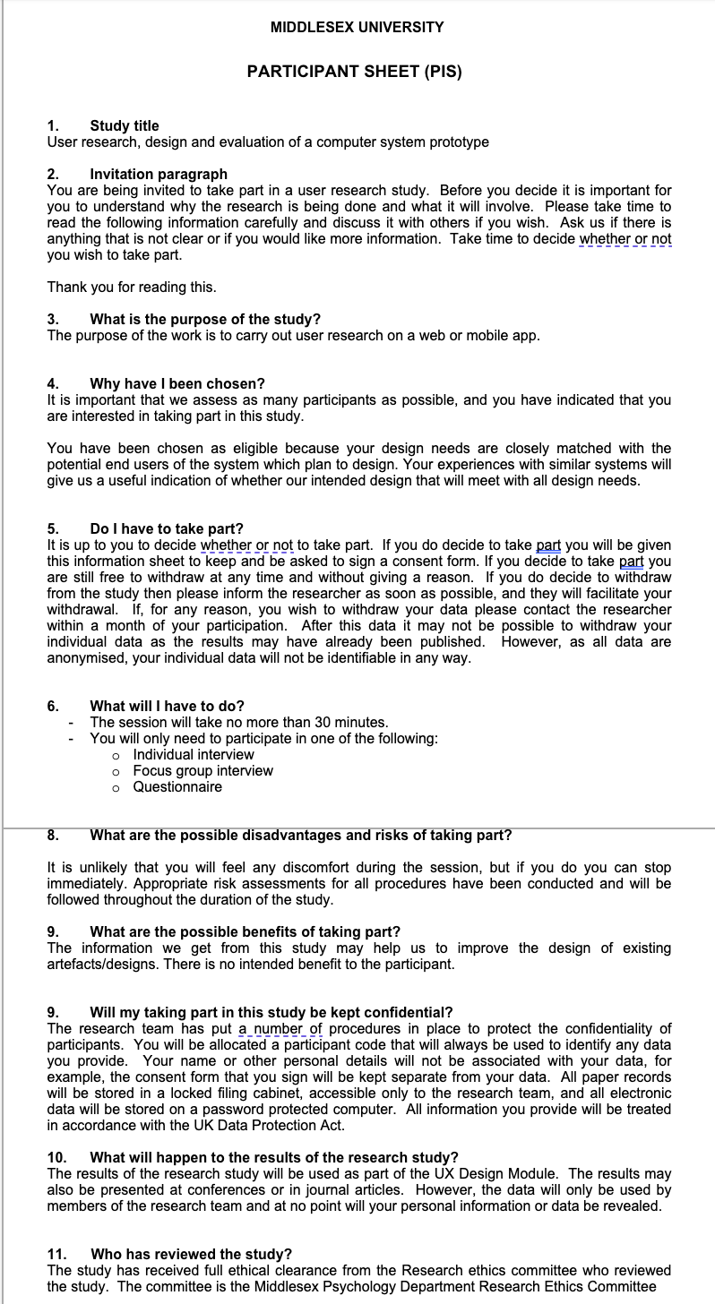

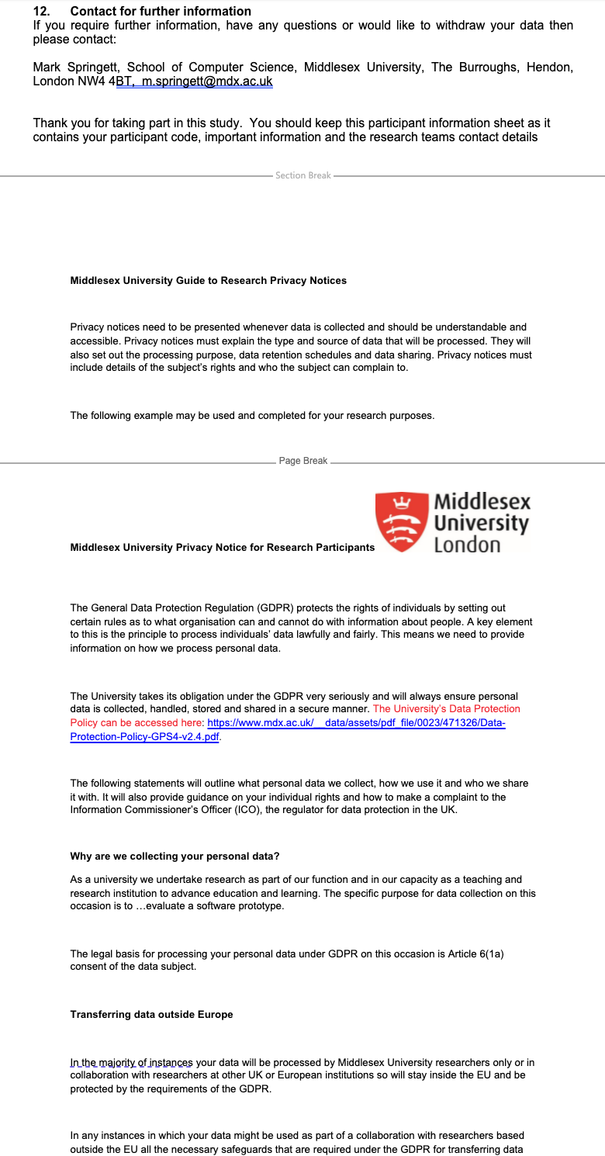

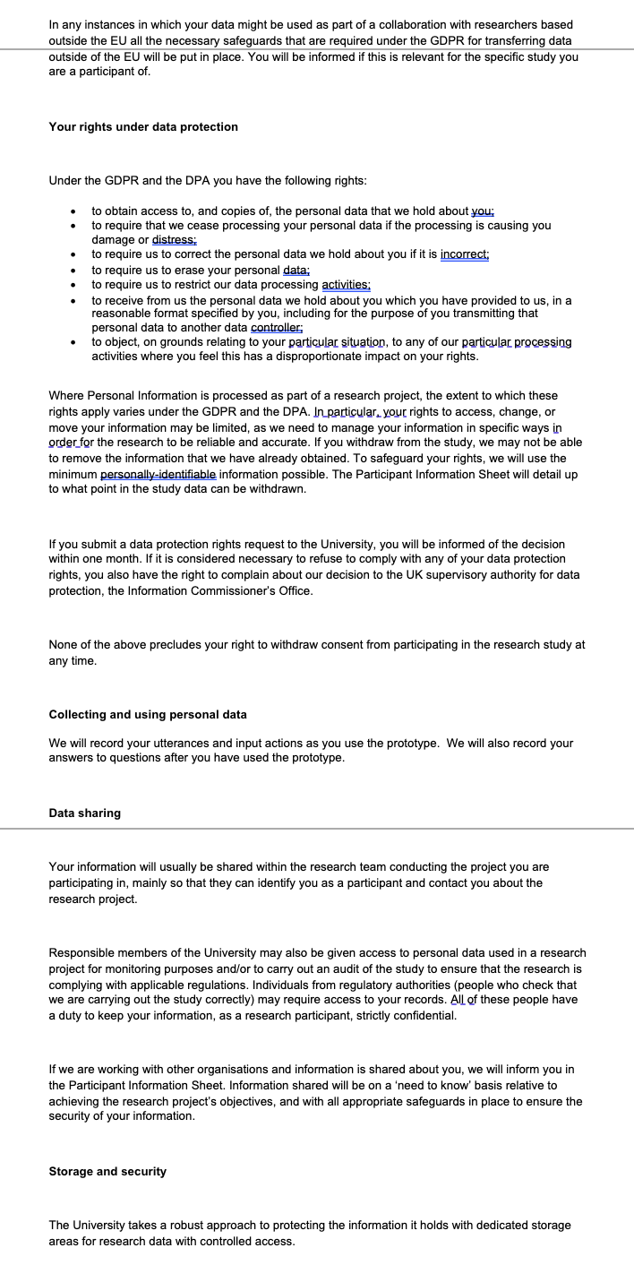

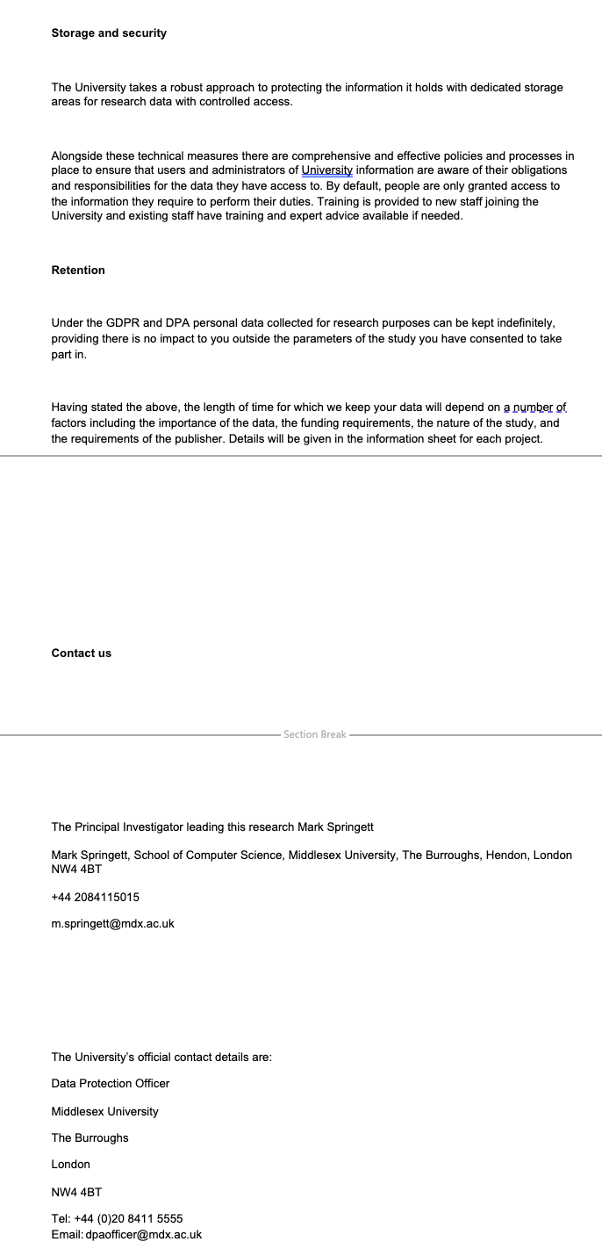

• Interview transcripts, questionnaires etc.

**Questionnaires**

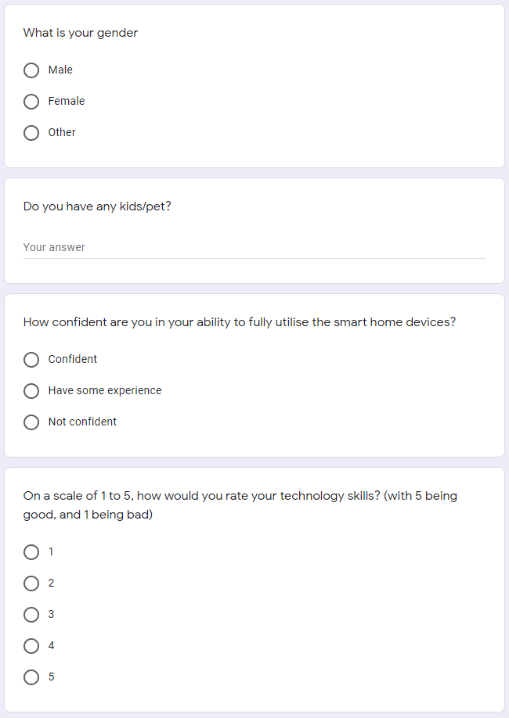

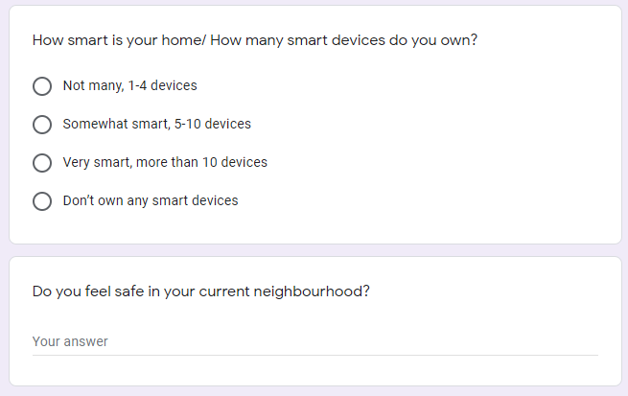

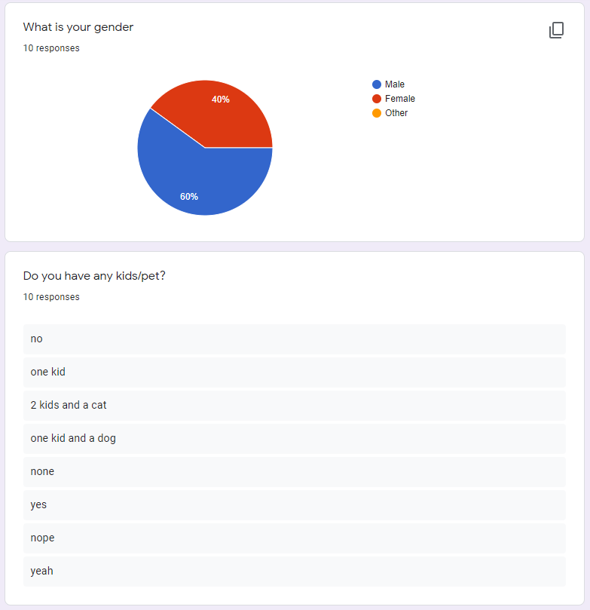

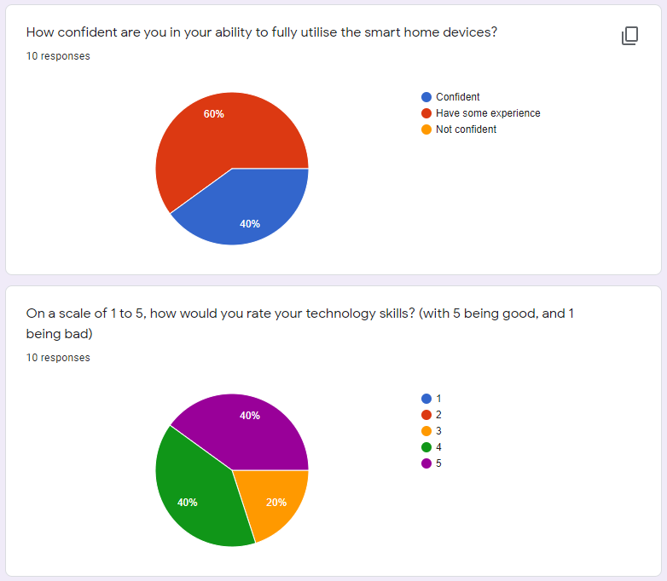

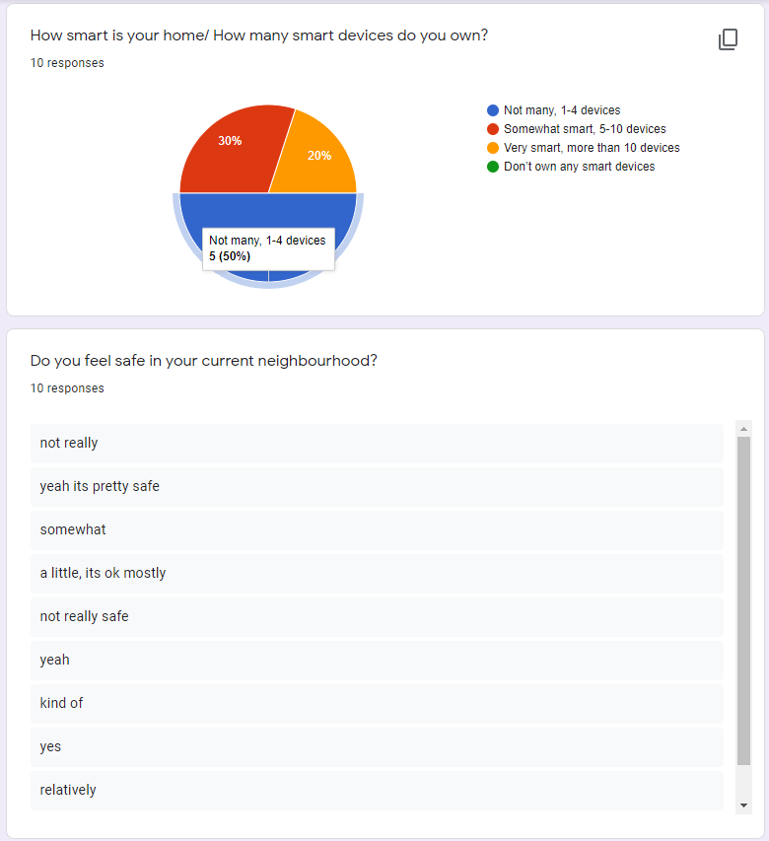

**Interview Transcript**

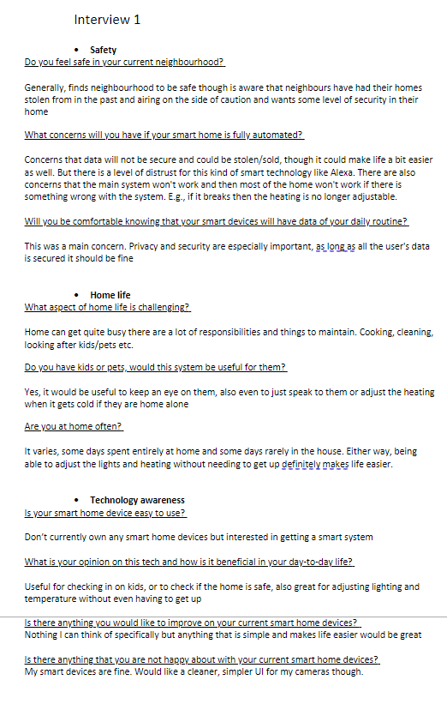

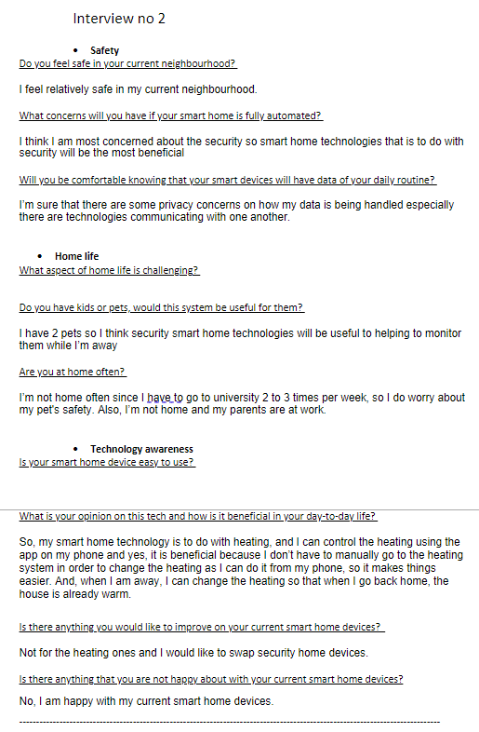

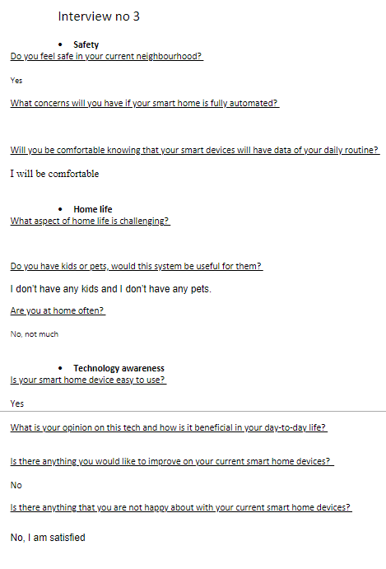

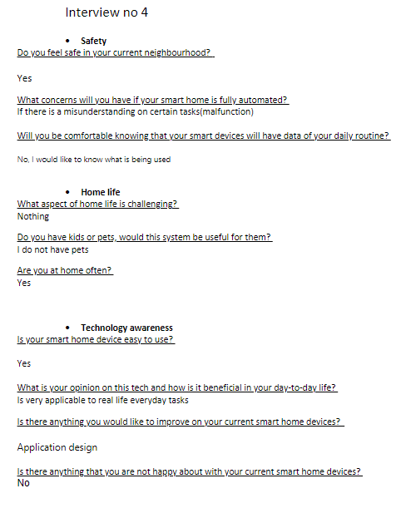

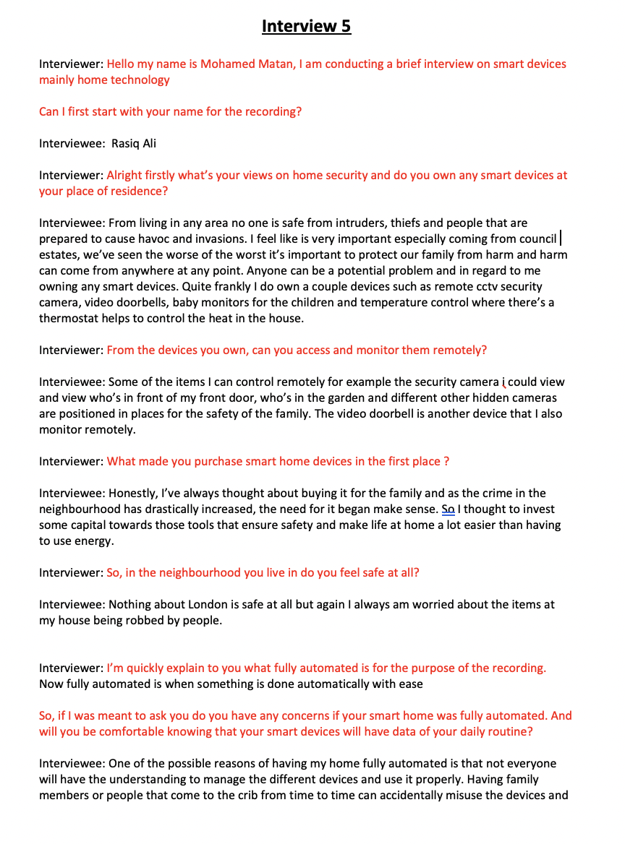

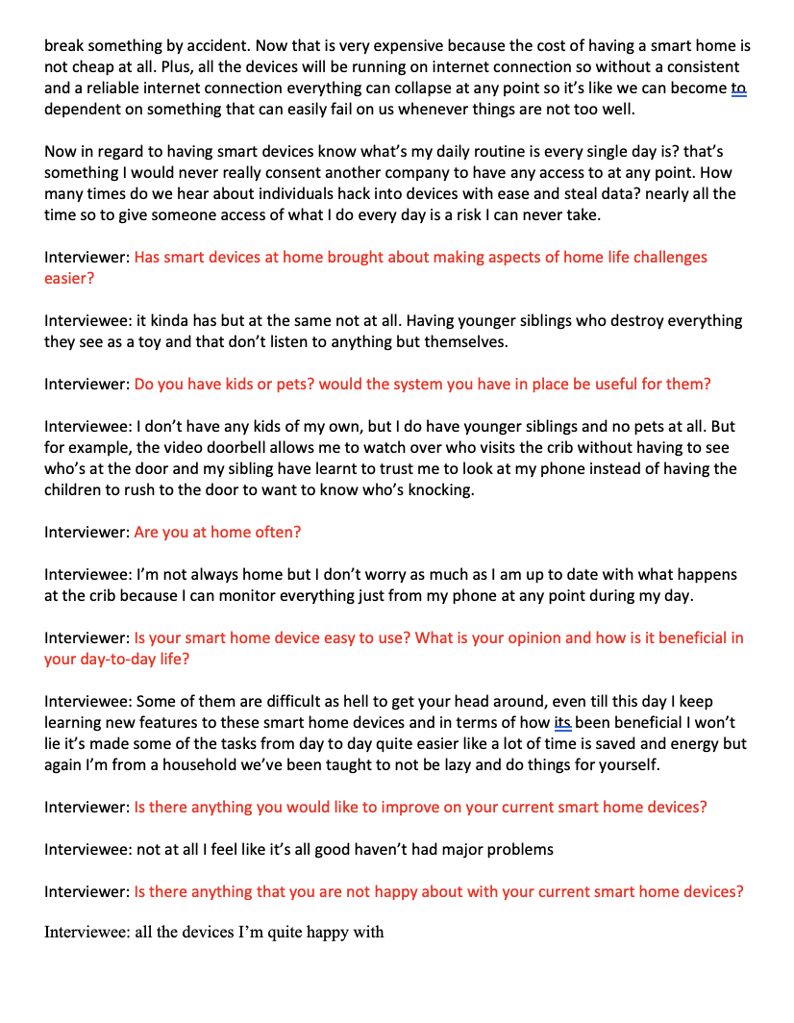

**Personas**

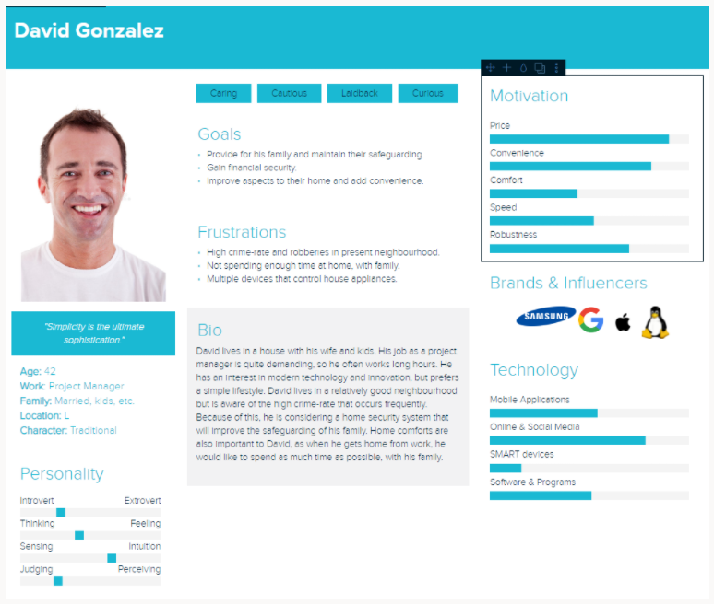

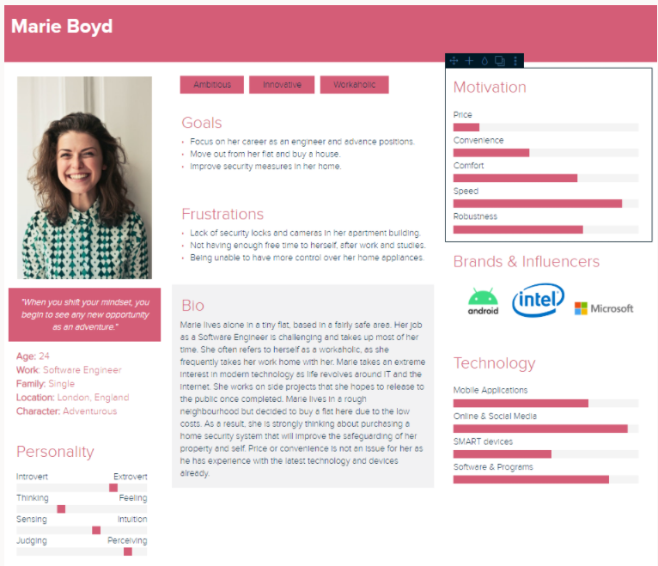

**User Stories**

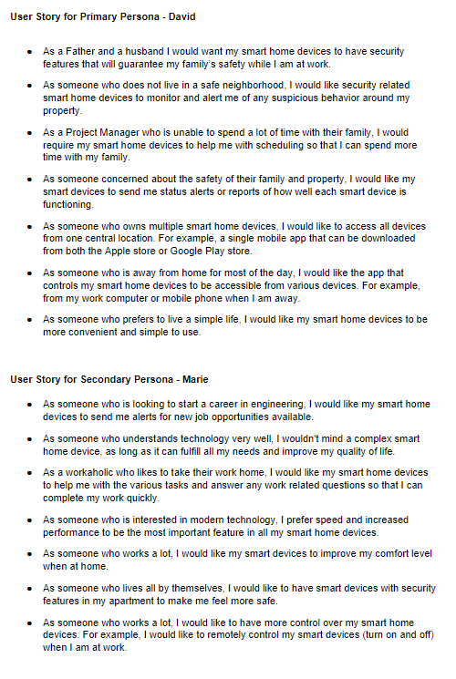

**User Journeys**

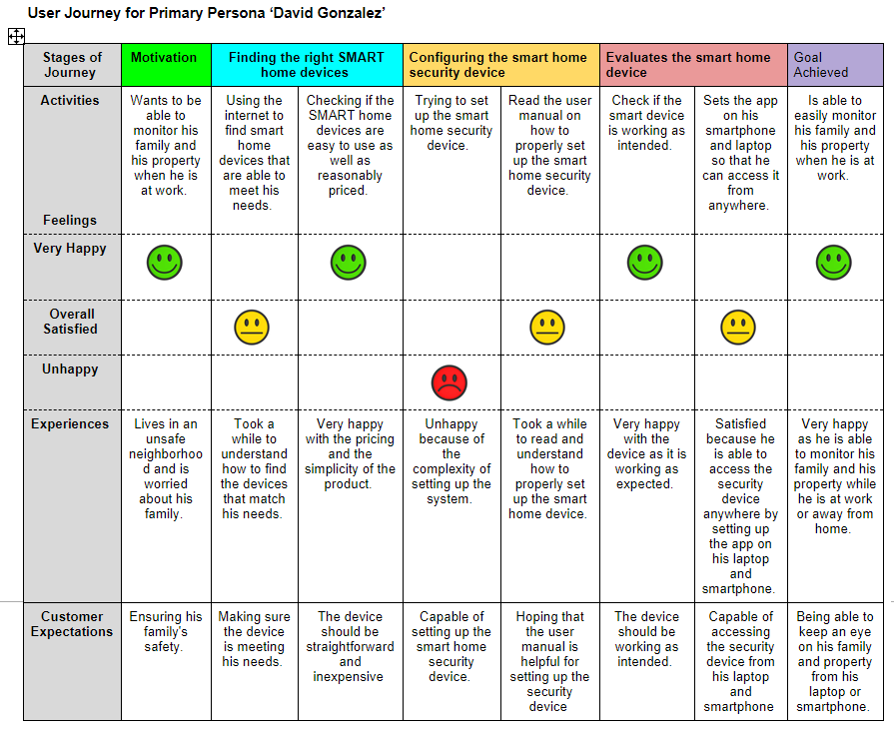

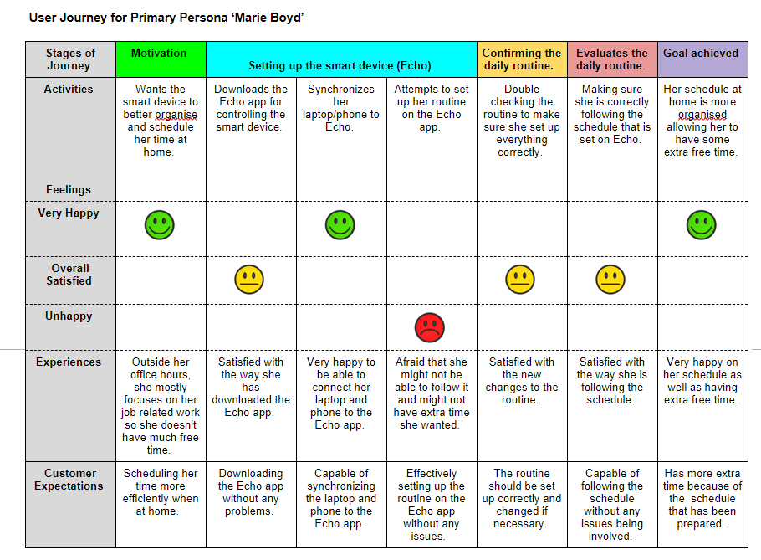

**UXI Matrix**

